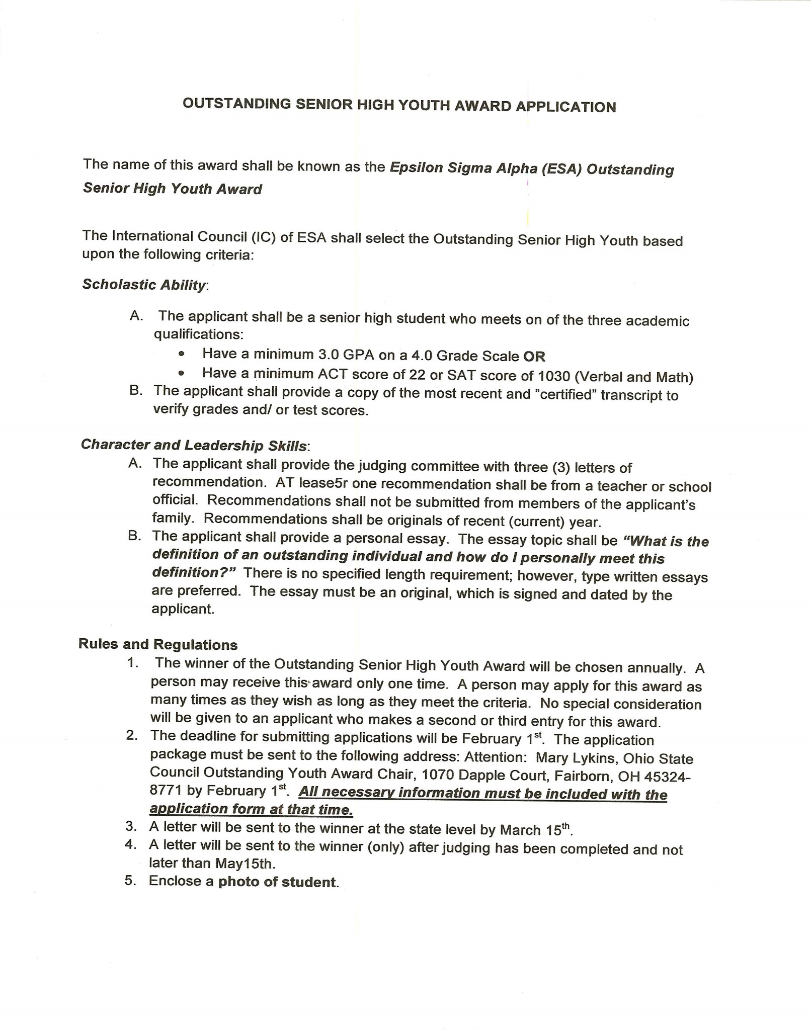

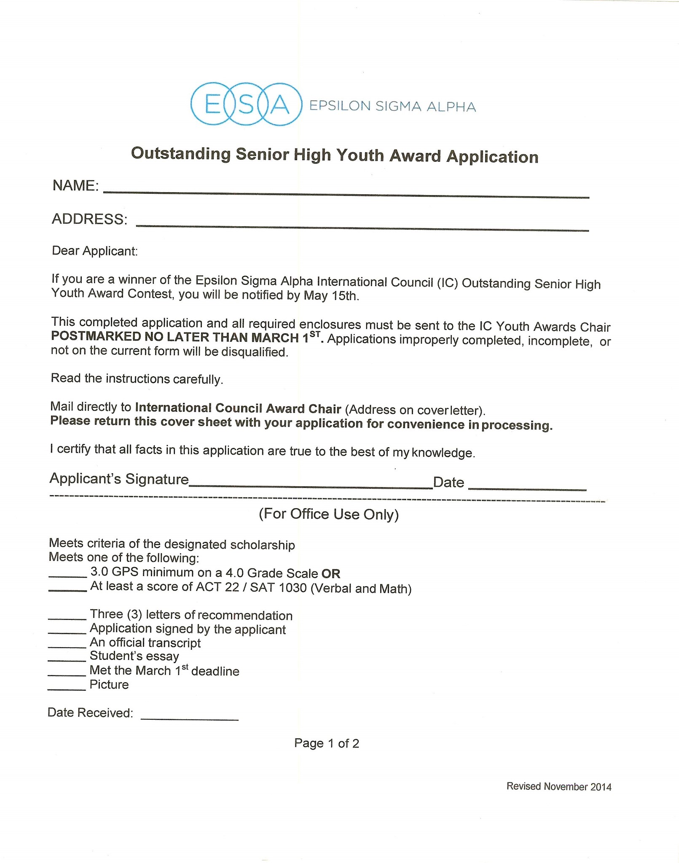

NAME: ______________________________________________________________________________

ADDRESS: ___________________________________________________________________________

